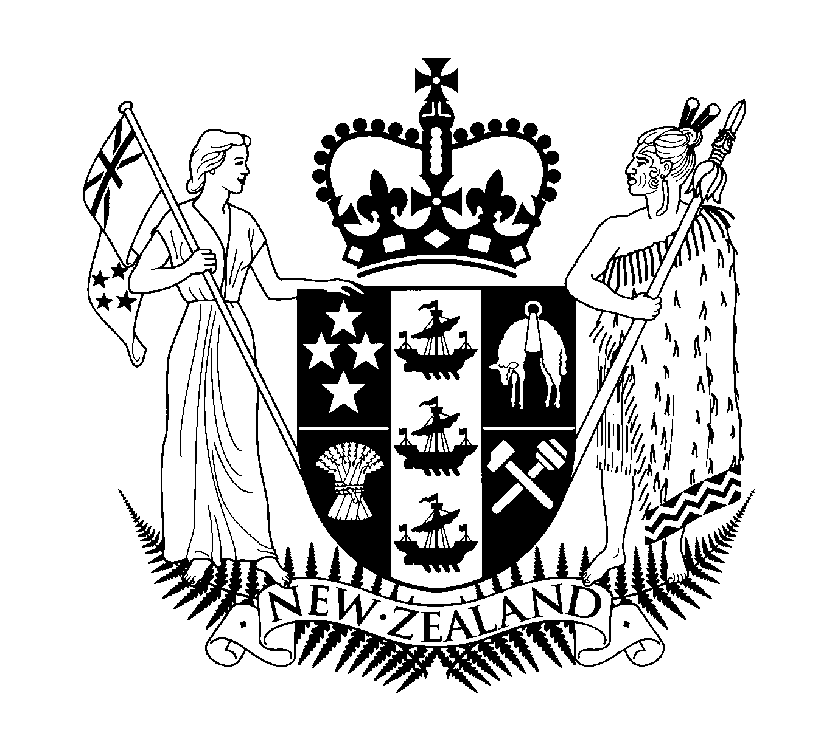

Hon Judith Tizard MP

Minister Assisting the Prime Minister with Auckland Issues

MP Auckland Central

Thursday, 27th July 2000
Addressing the Export Institute of New Zealand “Business After 5 Event”

Waipuna Lodge & Conference Centre
58 Waipuna Road, Mt Wellington
AUCKLAND

Introduction

Kia ora koutou. Greetings to you all.

Thank you for inviting me here this morning. It gives me great pleasure to speak to you about Auckland’s transport issues, and I am hopeful that once I’ve spoken you’ll share your thoughts on this important subject.

Prior to the Budget the Minister of Transport Mark Gosche and I spent a lot of time taking a thorough look at every aspect of the transport sector. We met with a wide range of people with an interest in transport – including many whose interest is specifically Auckland transport.

The message came through loud and clear - Aucklanders want a better transport system.

However there are no quick fixes. What this Government is doing is assembling the building blocks that will support a world class transport system.

Auckland Problems

The reality of daily life for most Aucklanders is that the roading system is all too often a barrier to social, educational and economic opportunity – rather than the access to opportunity that it should be.

One study estimates that Auckland’s congestion alone costs New Zealanders, not just Aucklanders, some $800 million plus per year.

During the last decade road traffic in New Zealand grew by 4% a year. At the present rate of growth traffic volumes will double in the next 18 years. Around Mangere Bridge the figure is closer to 12%!

While some of this congestion can only be measured in time and personal frustration, for the transport industry it is measured in financial costs – and that financial cost is added to the costs of the goods they carry and the services that they produce, so that we all pay.

You know the problems as well as I do:

- Our road infrastructure daily demonstrates that it is inadequate for the task that it is asked to do.

- The public transport system, which is a lifeline for the many Aucklanders who do not have cars, urgently needs upgrading and development.

- We face increasing pressure on our air and water resources.

- Transport noise is a serious problem in many residential and commercial areas.

- We still have a significant road safety problem.

- Pedestrians and cyclists face daily threats to their lives in many parts of the city.

Those are the problems that we as Aucklanders have to tackle. And at the same time the government must tackle the future of the whole New Zealand transport system as a concerted package. We cannot solve the “road safety problem” or the “passenger transport problem” or the “pedestrian problem” in isolation from each other.

Finding the answers

Tackling all these problems is a tall order, but I believe that we cannot let things go on as they are.

Developing a comprehensive approach will be a complex task and involve many groups and individuals.

The Government wants to work with local communities, industry groups and transport users to chart our path ahead.

Safety

We have begun that task by firstly addressing immediate safety issues.

We want to continue to improve our road safety record. Over the last decade, the road toll has been substantially reduced, but we are still well below the best results achieved by similar countries.

The Government has now made a series of decisions that will enable us to make substantial immediate improvements in road safety, while we develop a more strategic approach.

- From early 2001, 225 extra police officers will be working exclusively on road safety on the State Highways. These officers will staff the new Highway Patrol, which is designed to provide a high profile police presence on the most highly used part of the road system

- We have almost doubled the amount of money going to community road safety education with particular emphasis on initiatives coming from the Maori and Pacific Island communities.

- Additional police resources will be put into breath testing campaigns, especially in rural areas.

- The police will tighten the tolerances used in speed limit enforcement, and pay especial attention to the wearing of seat belts.

- New Zealand will join the Australian road vehicle crash test programme, so that consumers can have a better understanding of the safety record of vehicles they buy.

Together this package will cost more than $152 million over the next four years, and represents the first increase in road safety spending in nearly six years – something I believe this Government can be very proud of!

Hidden cameras trial

At the same time, the Government has decided not to proceed any further with the trial of hidden speed cameras that has been run in the Waikato for the last two years.

We believe that a higher and more visible police presence on the road network, together with the education measures that I just mentioned, will be a more effective way – and a more publicly acceptable way - to make a substantial and rapid reduction in the road toll.

Safety strategy to 2010

The Government is also considering a long term road safety strategy for the next ten years to 2010, which we plan to release for discussion in the near future. This is a crucially important decision affecting every one of us, and I am concerned that all interested parties give it the attention it deserves.

Over the last three years a wide variety of government and community organisations have worked together on this strategy, and the result does them credit.

The first key question in that strategy will be: How far can we push the road toll down over the next ten years?

If we adopt world best practice as our goal, then we are looking at a reduction in our road toll from just over 500 deaths per year to 280 per year. That is no mean target when we also expect substantial growth in traffic over the same period.

The second key question will be: How do we achieve our chosen road safety goal?

There is a wide range of possible options ranging from substantial increases in enforcement standards and activity through enhanced and improved education programmes to a massive programme of road rebuilding and improved ways of managing road infrastructure.

Each option has its costs, both social and financial, and the Government will be seeking wide community input into these issues before we set a long term direction later this year.

I believe your organisation would have some very useful insights into the strategy and I would urge you to get involved in the consultation process later this year.

Public transport

Aucklanders want a better public transport system. About 46% of those polled in a recent city council survey gave the thumbs up to improving existing roads and investing in public transport. Another 23% wanted investment in public transport alone. Interestingly only 10% said the answer to Auckland’s congestion is more roads and motorways.

The “build more roads” policy that Auckland has followed for the last 50 years has been at the cost of the public transport system.

We have continued to build roads while valuable passenger transport corridors, such as railways, are substantially underused.

Running down the public transport system has drastically reduced the range and quality of travel opportunities for those Aucklanders who do not have cars.

All too often, public transport today in Auckland means standing in the rain to wait for a bus or standing on a graffiti covered railway platform.

In this environment, we should not be surprised that public transport users in Auckland are predominantly those who have little other choice.

Few car users are going to switch their travel to public transport until the alternative is as good or better.

We must raise the quality of public transport service and its marketing.

Public transport announcement

As part of the Budget, the Government announced a series of immediate measures to begin the improvement of New Zealand’s public transport systems.

- The artificial limits on public transport spending imposed by the last Government have been abolished.

- From October this year, we will put in place a new system of funding that pays extra money to Regional Councils in direct proportion to the number of passengers using public transport in their region.

- Transfund New Zealand is reviewing the rate at which financial assistance is given to Regional Councils, with a view to increasing the share of funding from the National Roads Fund, thereby releasing additional regional funds for further passenger transport service improvements.

- Current requirements for cost effective expenditure will be kept in place.

We estimate that if Regional Councils seize these opportunities, as we expect they will, passenger transport funding from the National Roads Fund could rise from $46 million last year to $93 million in 2003, with large benefits in terms of accessibility in our major cities.

Effectively that means that the amount available for public transport could double in the next three years.

This total includes the major share of the funding for the North Shore Busway, currently the largest single passenger transport project in New Zealand, which will provide greatly improved passenger transport services across the Auckland region.

The Government is also reviewing the future of other elements of passenger transport funding, including the future management and funding of the Total Mobility scheme.

In conducting this review, I am particularly concerned that we focus on the actual needs of people in society.

While our mass transit systems clearly need development, I am also concerned that we have tended to overlook the importance of those services that provide door to door service.

Taxis and shuttles provide a crucial level of service to many in our community who do not have access to cars, in a way that buses, trains and ferries will never be able to do. I want to ensure that we make better use of them.

Roading

We cannot continue building roads for roads sake, as we have in the past, let me make that very clear. Los Angeles spent the twentieth century proving the truth that road traffic expands beyond capacity. I do not want to see New Zealand spend the twenty first century proving the same thing.

However we certainly need some new roads as our economy grows and changes, and freight access to industry, ports and airports is clearly a priority.

The Auckland Regional Land Transport Strategy, which was published last year, recognised that we have to consider the future management of our roading system, including a careful assessment of the introduction of congestion pricing.

The government agrees. We have to do better in managing our roading system.

Road infrastructure solutions

The Government’s manifesto set out a number of areas for road management and investment that we wanted to explore, and our discussions with sector groups have raised a number of other issues.

I believe from those discussions with a wide range of interested individuals and groups that there is a general consensus that we need to change the way we manage and fund our land transport system. Many people believe that we need to find better ways of charging for road use, and that some changes to management structures are desirable.

I believe there is now a growing consensus that we can make pragmatic progress this year in three main areas:

- We need to work with our roading partners on systems to manage the external impacts of the road system, including improving safety and environmental management and our public transport system. In doing this, we need to make it clear that road corridors are for a wide variety of users, including pedestrians and cyclists. They, just as much as motorists, have a right to use road corridors in safety.

- Secondly, we need to examine, with our roading partners, the way in which we charge for roads. New technology now enables us to consider new methods of payment and charging within the existing Road User Charges system. For example, we can look to measure more precisely the loads that heavy vehicles are carrying. We also need to consider whether the present funding system can be made simpler, while retaining its basic principle of cost effectiveness.

- We want to talk with the other stakeholders about whether our present management structures can be improved in a gradual way, without generating any more of the upheavals that have characterised reforms in the past.

The road system has to be improved.

It is not just a matter of dealing with a few high profile road projects. We have to put systems in place which ensure real value for money and let us prioritise our investment. The rules need to be clear and fair. We want to take decisions without the constant air of impending crisis that too often seems to characterise land transport investment.

I believe that we have an excellent opportunity to do that this year, and I look forward to working with sector groups to achieve that goal.

Last week at the Local Government Conference the Minister of Transport, Mark Gosche, announced that consultation on these issues is about to begin, so that the Government can make decisions on these issues by the end of the year.

We want this consultation to be pragmatic and productive.

The last Government spent five years debating the issues but could not reach a practical solution to our road problems.

It is time to make real progress and give everyone a clear direction for the future.

Transfund Announcement

While I am on the subject of roads, I must acknowledge the excellent recent news from Transfund that it has been able to increase its total land transport funding by 27 percent, compared to only four years ago.

Because of growth in the economy and the fact that New Zealand’s roading systems are providing great value for money, they will have about $940 million to spend on this year’s National Roading Programme.
.
About 22 percent of this – that’s about $170.8 million - will be devoted to Auckland’s needs, which acknowledges the region’s rapid growth and the ever increasing demands on its infrastructure.

The Auckland allocation includes about $67 million for new roads, $81 million for maintaining the existing road network and $21 million for passenger transport . And the Auckland total could grow by between $25 million and $50 million as projects in the pipeline receive approval during the year - all of which is great news for Auckland!

Pedestrians and Cyclists

I’d like now to briefly talk about pedestrians and cyclists. I believe we need to pay more attention to the needs of these groups.

Every trip by car includes a pedestrian component, yet we often seem to forget this aspect.

We tend to forget that for many New Zealanders our roads can be a frightening experience.

We have to have a road system that is safe for senior citizens who daily have to cross busy roads to get to the shops or the doctor.

We have to have a road system that is safe for our children going to and from school.

The medical profession and the Hilary Commission tell us of the health benefits of walking or cycling – yet too often we provide a transport environment that is totally hostile to anything other than motor vehicles.

We must manage our road corridors so that pedestrians and cyclists are safe.
.

Environment

New Zealand relies heavily on its “clean green” image to market itself in a world that is increasingly concerned about the environment.

Improving the reality of our environment to match the marketing image is a high priority for this Government, and the transport sector will play an important part in that task.

We need to improve the emission performance of the vehicle fleet. Before the end of this year, the Government expects to put in place new emission standards for all vehicles arriving in New Zealand for the first time.

I have already mentioned the improvements to public passenger transport in our major cities. Of course an important benefit of such an improvement could be a reduction in vehicle emissions.

I also believe that we need to review those sections of the Resource Management Act that deal with land transport. I can see no valid reason why roads and railways should be exempt from the air emissions requirements of that Act. I strongly believe that new road and rail projects would greatly benefit from public evaluation and monitoring of their impacts, as part of the wider community overview of the environment. We will be talking with stakeholders about this.

Indeed, the Ministry of Transport has been working closely with local authorities in Auckland and Christchurch to develop the systems for such evaluation and monitoring, and the results of that co-operation will be made widely available in the near future.

We are also working on new rules to govern smoky road vehicles. While the intent of the current law is a good one, its administration is unreasonably complex, and plans for a simpler, approach to dealing with smoky vehicles are well advanced.

Scientific research into the impacts of land transport on water runoff is also well underway, as is research into the impacts of noise on communities.

Kyoto Protocol

The Government has decided to accede to the Kyoto Protocol on Climate Change in the second half of 2002.

This means that we will be making a commitment that by 2008 we will have reduced our net greenhouse gas emissions to no more than they were in 1990.

This is no small task.

Currently the transport sector generates about 15% of New Zealand’s total greenhouse gas emissions. The bulk of those emissions are CO2 generated by the burning of fossil fuel on our roads.

This means that we are going to have to make a serious effort to improve road vehicle fuel efficiency.

We will need to ensure that our vehicle fleet reflects the latest propulsion technologies – such as hybrid systems and fuel cells - as soon as they are available. The new vehicle standards I mentioned earlier will encourage this.

We will also have to make a major effort to reduce traffic congestion in our major cities, including Auckland.

If we reduce congestion we not only get a more efficient economy – we also reduce the emission impacts on the environment and cut the production of greenhouse gases.

Making progress on climate change is a high priority for the Government, and we plan to work closely with the key groups in the sector. If we work together in a pragmatic way, I believe that we can both meet our environmental goals, while making more efficient use of our transport system.

Bringing it all together

If the transport sector is to support a positive future for New Zealand, then we have to work towards a sustainable transport system.

Uniting all the elements that I have discussed into a comprehensive package that sets a clear path for the whole transport sector is a complex exercise, but one to which we are committed.

The Government intends to develop, with stakeholders, a New Zealand Transport Strategy to bring together all the issues I have discussed today into a comprehensive package that will give certainty for future investment and development.

The New Zealand Transport Strategy will have to set long term directions in terms of safety, environmental performance and accessibility. It will emphasise that the core issues of investment and innovation will depend on a commercially focussed transport and distribution sector that will thrive by providing high quality service to all its users.

Conclusion

That leads me back to co-operation and dialogue.

It has long been my experience that problems only get worse when people cannot sit down together and try and find pragmatic solutions to their problems.

That is the key message in this Government’s approach to the transport portfolio.

In the next three years, this government is going set a co-ordinated strategic course that will enable us to begin the highly complex task of tackling those problems.

We have to deal with transport problems in the wider context of social, environmental and economic problems.

We cannot do it alone, and we want to involve a wide range of people and community groups in developing those solutions. I look forward to working with your group in doing that.

